**5x5x4 Tic Tac Toe**

**Software Quality Assurance Plan**

**Version: (1) Date: (10/30/2016)**

**Document History and Distribution**

1. Revision History

|  |  |  |  |
| --- | --- | --- | --- |
| Revision # | Revision Date | **Description of Change** | **Author** |
| 1 | 10/30/2016 | Testing | Andrew Montano |
| 2 | 12/04/2016 | Final Draft | Andrew Montano |
|  |  |  |  |
|  |  |  |  |
|  |  |  |  |
|  |  |  |  |

1. Distribution

|  |  |  |
| --- | --- | --- |
| Recipient Name | Recipient Organization | **Distribution Method** |
| Team | Students |  |
|  |  |  |
|  |  |  |
|  |  |  |
|  |  |  |
|  |  |  |

**Table of Contents**

1. Introduction 1

2. Test Items 3

3. Features To Be Tested 4

4. Features Not To Be Tested 4

5. Approach 4

6. Pass / Fail Criteria 6

7. Testing Process 6

8. Environmental Requirements 7

9. Change Management Procedures 8

10. Plan Approvals 8

# Introduction

(Note 1: The Software Test Plan guidelines were derived and developed from IEEE Standard for Software Test Documentation (829-1998)).

*(Note 2: The ordering of Software Test Plan (STP) elements is not meant to imply that the sections or subsections must be developed or presented in that order. The order of presentation is intended for ease of use, not as a guide to preparing the various elements of the Software Test Plan. If some or all of the content of a section is in another document, then a reference to that material may be listed in place of the corresponding content.)*

*The Introduction section of the Software Test Plan (STP) provides an overview of the project and the product test strategy, a list of testing deliverables, the plan for development and evolution of the STP, reference material, and agency definitions and acronyms used in the STP.*

**The Software Test Plan (STP) is designed to prescribe the scope, approach, resources, and schedule of all testing activities. The plan must identify the items to be tested, the features to be tested, the types of testing to be performed, the personnel responsible for testing, the resources and schedule required to complete testing, and the risks associated with the plan**.

**1.1 Objectives**

*(Describe, at a high level, the scope, approach, resources, and schedule of the testing activities. Provide a concise summary of the test plan objectives, the products to be delivered, major work activities, major work products, major milestones, required resources, and master high-level schedules, budget, and effort requirements.)*

The test plan document will describe the testing procedure for the 5x5x4 Tic Tac Toe Game to investigate the correctness of the application. This will be done by recognizing project information and software to be tested. Identify the resources needed and provide an estimate of the test efforts. Elaborate on the testing strategies to be employed.

**1.2 Testing Strategy**

**Testing is the process of analyzing a software item to detect the differences between existing and required conditions and to evaluate the features of the software item.** (*This may appear as a specific document (such as a Test Specification), or it may be part of the organization's standard test approach. For each level of testing, there should be a test plan and an appropriate set of deliverables. The test strategy should be clearly defined and the Software Test Plan acts as the high-level test plan. Specific testing activities will have their own test plan. Refer to section 5 of this document for a detailed list of specific test plans.)*

*Specific test plan components include:*

* *Purpose for this level of test,*
* *Items to be tested,*
* *Features to be tested,*
* *Features not to be tested,*
* *Management and technical approach,*
* *Pass / Fail criteria,*
* *Individual roles and responsibilities,*
* *Milestones,*
* *Schedules, and*
* 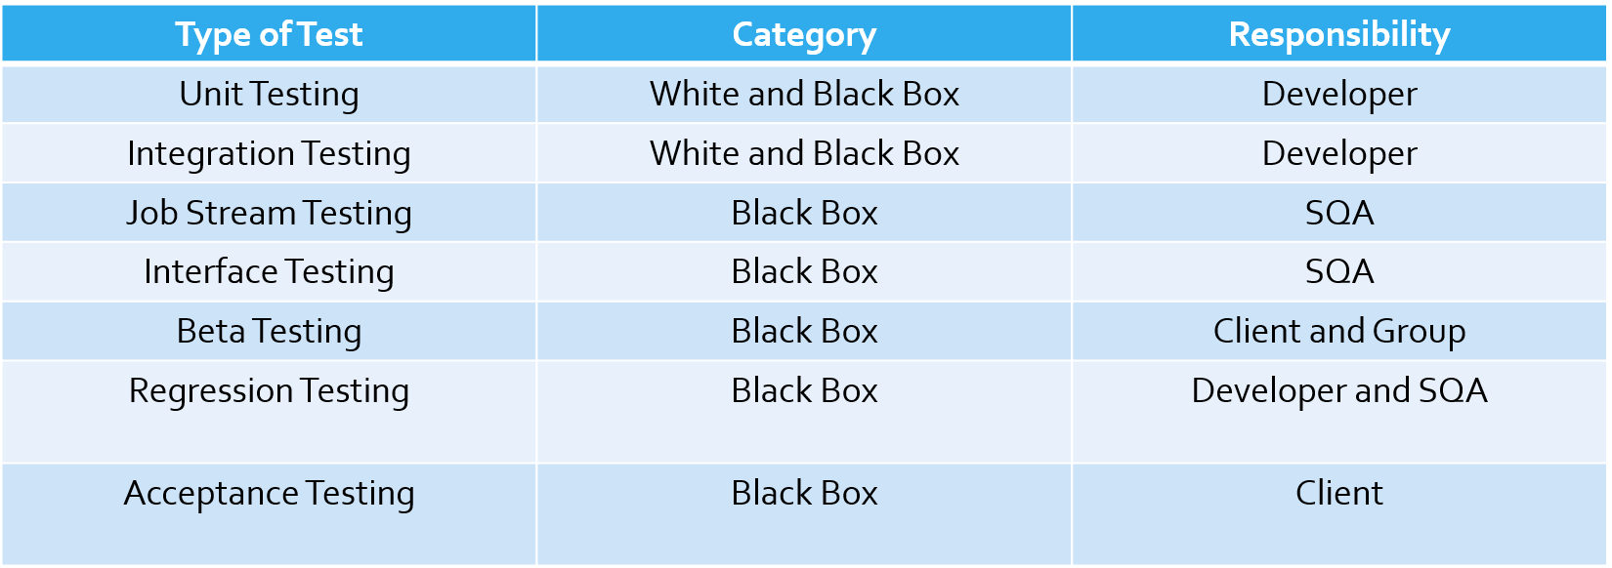*Risk assumptions and constraints.*

**1.3 Scope**

*(Specify the plans for producing both scheduled and unscheduled updates to the Software Test Plan (change management). Methods for distribution of updates shall be specified along with version control and configuration management requirements must be defined.)*

**Testing will be performed at several points in the life cycle as the product is constructed. Testing is a very 'dependent' activity. As a result, test planning is a continuing activity performed throughout the system development life cycle. Test plans must be developed for each level of product testing.**

**1.4 Reference Material**

*(Provide a complete list of all documents and other sources referenced in the Software Test Plan. Reference to the following documents (when they exist) is required for the high-level test plan:*

* *Project authorization,*
* *Project plan,*
* *Quality assurance plan,*
* *Configuration management plan,*
* *Organization policies and procedures, and*
* *Relevant standards.)*

Chapter 6 Testing -Object Oriented and Classical Software Engineering 8th edition

Chapter 13 OOA-Object Oriented and Classical Software Engineering 8th edition

**1.5 Definitions and Acronyms**

*(Specify definitions of all terms and agency acronyms required to properly interpret the Software Test Plan. Reference may be made to the Glossary of Terms on the IRMC web page.)*

# Test Items

*(Specify the test items included in the plan. Supply references to the following item documentation:*

* *Requirements specification,*
* *Design specification,*
* *Users guide,*
* *Operations guide,*
* *Installation guide,*
* *Features (availability, response time),*
* *Defect removal procedures, and*
* *Verification and validation plans.)*

1. Use Cases

2. Function requirements

3. Test cases

4. Requirement document

5. Specification Document

6. SMSP

7. Detail Design

**2.1 Program Modules**

*(Outline testing to be performed by the developer for each module being built.)*

The team tested each module as we built it.

**2.2 Job Control Procedures**

*(Describe testing to be performed on job control language (JCL), production scheduling and control, calls, and job sequencing.)*

**2.3 User Procedures**

*(Describe the testing to be performed on all user documentation to ensure that it is correct, complete, and comprehensive.)*

Execution Testing

Non-Execution Testing

Inspection

Test all the User Interface buttons, the username text fields, the scoring and the game grid.

1 or 2 persons responsible for 1 document

Group decided if changes were acceptable

**2.4 Operator Procedures**

*(Describe the testing procedures to ensure that the application can be run and supported in a production environment (include Help Desk procedures)).*

# 3. Features To Be Tested

*(Identify all software features and combinations of software features to be tested. Identify the test design specifications associated with each feature and each combination of features.)*

The “Player 1”, “Player 2”, “Match Scores” options, AI and its difficulty, creating a new profile and selecting an old profile, game piece selection and who goes first, the cells in the game grid, winning condition saving the score to the profiles and the time it took in the game.

# 4. Features Not To Be Tested

*(Identify all features and specific combinations of features that will not be tested along with the reasons.)*

None

# 5. Approach

*(Describe the overall approaches to testing. The approach should be described in sufficient detail to permit identification of the major testing tasks and estimation of the time required to do each task. Identify the types of testing to be performed along with the methods and criteria to be used in performing test activities. Describe the specific methods and procedures for each type of testing. Define the detailed criteria for evaluating the test results.)*

*(For each level of testing there should be a test plan and the appropriate set of deliverables. Identify the inputs required for each type of test. Specify the source of the input. Also, identify the outputs from each type of testing and specify the purpose and format for each test output. Specify the minimum degree of comprehensiveness desired. Identify the techniques that will be used to judge the comprehensiveness of the testing effort. Specify any additional completion criteria (e.g., error frequency). The techniques to be used to trace requirements should also be specified.)*

**5.1 Component Testing**

*(Testing conducted to verify the implementation of the design for one software element (e.g., unit, module) or a collection of software elements. Sometimes called unit testing. The purpose of component testing is to ensure that the program logic is complete and correct and ensuring that the component works as designed.)*

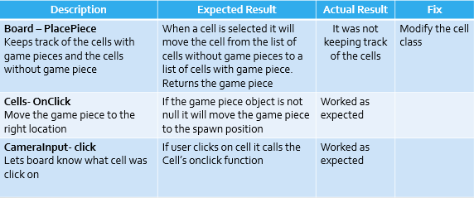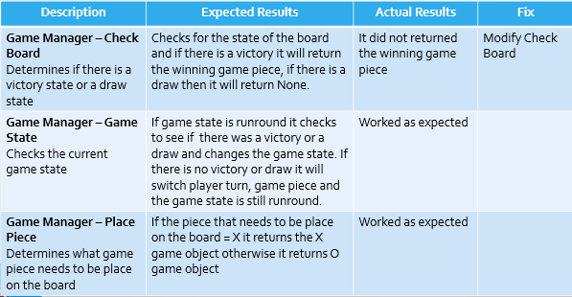

**5.2 Integration Testing**

*(Testing conducted in which software elements, hardware elements, or both are combined and tested until the entire system has been integrated. The purpose of integration testing is to ensure that design objectives are met and ensures that the software, as a complete entity, complies with operational requirements. Integration testing is also called System Testing.)*

* Make sure the when using a public function from a different class is spelled right has the right arguments and in the same order.
* Pay attention to the names of the classes.

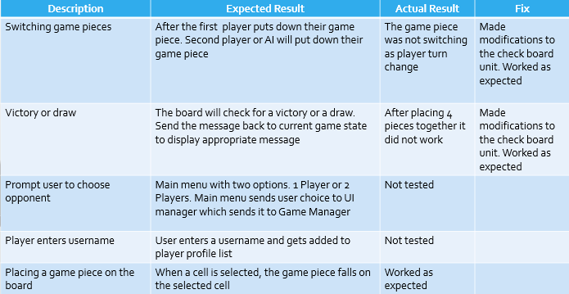

**5.3 Conversion Testing**

*(Testing to ensure that all data elements and historical data is converted from an old system format to the new system format.)*

Not applicable

**5.4 Job Stream Testing**

*(Testing to ensure that the application operates in the production environment.)*

Tested the prototype on 11/1/16 in the computers of University of Houston-Downtown computer lab. Also did a live presentation show the prototype to the class.

**5.5 Interface Testing**

*(Testing done to ensure that the application operates efficiently and effectively outside the application boundary with all interface systems.)*

Test interface against requirements and specification’s user interface. Make sure all the buttons that switch screens do so and fields that take text can handle text.

**5.6 Security Testing**

*(Testing done to ensure that the application systems control and auditability features of the application are functional.)*

**5.7 Recovery Testing**

*(Testing done to ensure that application restart and backup and recovery facilities operate as designed.)*

**5.8 Performance Testing**

*(Testing done to ensure that that the application performs to customer expectations (response time, availability, portability, and scalability)).*

|  |  |  |
| --- | --- | --- |
| **Description** | **Expected Results** | **Actual Results** |
| Software environment | Runs in Windows | Runs in Windows |
| Make sure game piece falls within a reasonable time | Game piece falls under 3 seconds after cell has been clicked | 3 second average |

**5.9 Regression Testing**

*(Testing done to ensure that that applied changes to the application have not adversely affected previously tested functionality.)*

After testing the artifact, the person who worked on the artifact has to make changes to fix the bugs, and also test other areas to make sure nothing broke.

**5.10 Acceptance Testing**

*(Testing conducted to determine whether or not a system satisfies the acceptance criteria and to enable the customer to determine whether or not to accept the system. Acceptance testing ensures that customer requirements' objectives are met and that all components are correctly included in a customer package.)*

Test that the product built satisfies the clients requirements and specifications. Test will be done by the client.

**5.11 Beta Testing**

*(Testing, done by the customer, using a pre-release version of the product to verify and validate that the system meets business functional requirements. The purpose of beta testing is to detect application faults, failures, and defects.)*

Will be done by Professor Yuan on 12/6/2016

# 6. Pass / Fail Criteria

*(Specify the criteria to be used to determine whether each item has passed or failed testing.)*

For non execution based testing the document will pass if the whole team agrees, if it does not pass person in charge of document goes back fix and tells group of follow up.

For execution based testing if the product does what is expected then it passes other wise it fails.

**6.1 Suspension Criteria**

(*Specify the criteria used to suspend all or a portion of the testing activity on test items associated with the plan.)*

Unit testing is suspended for a unit only when a unit has been tested, and all integrations for that unit have been tested, and no additional integrations have been made for that unit.

**6.2 Resumption Criteria**

*(Specify the conditions that need to be met to resume testing activities after suspension. Specify the test items that must be repeated when testing is resumed.)*

A unit test is resumed if any unit has received additional integration from another unit

**6.3 Approval Criteria**

*(Specify the conditions that need to be met to approve test results. Define the formal testing approval process.)*

Individual are responsible for unit testing their deliverable. When a unit is completed, the integration developer is responsible for integration testing

# 7. Testing Process

*(Identify the methods and criteria used in performing test activities. Define the specific methods and procedures for each type of test. Define the detailed criteria for evaluating test results.)*

For execution based testing we will use test cases and if the program does what is expected then it passes the test, otherwise the programmer goes back to fix it and do the test again until it passes.

For non-execution based testing after changes have been done to the document by the person in charge the whole team agrees if the changes are acceptable or not.

**7.1 Test Deliverables**

*(Identify the deliverable documents from the test process. Test input and output data should be identified as deliverables. Testing report logs, test incident reports, test summary reports, and metrics' reports must be considered testing deliverables.)*

Test Cases

**7.2 Testing Tasks**

*(Identify the set of tasks necessary to prepare for and perform testing activities. Identify all intertask dependencies and any specific skills required.)*

Before inspection each developer will study the document and make notes before meeting, done as a team.

Developers must collect the most recent code base before performing unit testing. Testing must be done completely before making any modifications to the code base.

**7.3 Responsibilities**

*(Identify the groups responsible for managing, designing, preparing, executing, witnessing, checking, and resolving test activities. These groups may include the developers, testers, operations staff, technical support staff, data administration staff, and the user staff.)*

Each developer is responsible for each unit they work on.

Tommy White oversees integration testing, he also made sure everyone was doing high quality work and has been involved in every step of the software development.

**7.4 Resources**

*(Identify the resources allocated for the performance of testing tasks. Identify the organizational elements or individuals responsible for performing testing activities. Assign specific responsibilities. Specify resources by category. If automated tools are to be used in testing, specify the source of the tools, availability, and the usage requirements.)*

Time out everyone's schedule

**7.5 Schedule**

*(Identify the high level schedule for each testing task. Establish specific milestones for initiating and completing each type of test activity, for the development of a comprehensive plan, for the receipt of each test input, and for the delivery of test output. Estimate the time required to do each test activity.)*

*(When planning and scheduling testing activities, it must be recognized that the testing process is iterative based on the testing task dependencies.)*

Unit testing done by 11/10/16

Integration testing done by 11/16/16

System testing done by 11/30/16

The plan is to finish the game before 12/04/2016

# 8. Environmental Requirements

(Specify both the necessary and desired properties of the test environment including the physical characteristics, communications, mode of usage, and testing supplies. Also provide the levels of security required to perform test activities. Identify special test tools needed and other testing needs (space, machine time, and stationary supplies. Identify the source of all needs that is not currently available to the test group.)

**8.1 Hardware**

*(Identify the computer hardware and network requirements needed to complete test activities.)*

All the testing so far has been on windows operating systems

**8.2 Software**

*(Identify the software requirements needed to complete testing activities.)*

The team has been using the Unity Game Engine and Visual Studio 2015. We have look at the logs for errors and from both Unity and Visual Studio.

**8.3 Security**

*(Identify the testing environment security and asset protection requirements.)*

**8.4 Tools**

*(Identify the special software tools, techniques, and methodologies employed in the testing efforts. The purpose and use of each tool shall be described. Plans for the acquisition, training, support, and qualification for each tool or technique.)*

* Unity
* Visual Studio

**8.5 Publications**

*(Identify the documents and publications that are required to support testing activities.)*

**8.6 Risks and Assumptions**

*(Identify significant constraints on testing such as test item availability, test resource availability, and time constraints. Identify the risks and assumptions associated with testing tasks including schedule, resources, approach and documentation. Specify a contingency plan for each risk factor.)*

No budget is required for testing.

Time out of everyone’s schedule

# 9. Change Management Procedures

*(Identify the software test plan change management process. Define the change initiation, change review, and change authorization process.)*

# 10. Plan Approvals

*(Identify the plan approvers. List the name, signature and date of plan approval.)*

Tommy White, Stephanie De La O, Huan Luu, Andrew Montano